|  |  |  |  |
| --- | --- | --- | --- |
| **QC Barcode Laser Scanner System Setup and Configuration** | | | |
| Author: | Joel Manning | Revision: | 1.0 |
| Date: | 14/02/2021 | Engineer Signed: | Lee Milward |

Contents

QC Barcode Printer V2 Setup and Configuration 3

Introduction 3

System from Scratch Setup 4

Operating the Nova pcb_print Software 9

Decoding Scanned Barcodes 10

# QC Barcode Printer V2 Setup and Configuration

## Introduction

The following document is a breakdown of the system setup, configuration, and usage of the software interface. It will include the calibration of the system through the Keyence AutoID Network Navigation software.

The barcode printing system has been updated to include the following equipment:

* Keyence SR750 Scanner
* Trigger Sensor
* Zebra Printer
* PC
* Printing Realer

The SR750 Scanner works in conjunction with the trigger sensor to scan each barcode that is printed by the zebra printer. The scanner is configured to feedback an error code if a barcode is either:

* Non-Existent
* Poor Quality
* Poor Hardware Calibration

The trigger sensor must be aligned to the target barcode as accurately as possible. Misalignment will result in bad reads by the sensor and therefore failing to accurately scan each print job.

The SR750 scanner will require calibration during an initial setup of the equipment, these steps are outlined throughout the document.

The pcb_print software has been modified to accept up to **five** consecutive fails in reading barcodes before the software will stop the printing process. This threshold can be modified at the software level depending on the level of acceptable tolerance.

When consecutive fails have been logged then the printing process will cease. And an error will be shown on the PC monitor notifying the responsible operator. It is recommended when this occurs that the responsible operator remove the faulty labels, reset, and restart the print job.

It should be noted that the steps undertaken in this document are not required to be undertaken each time a print job only upon first time use of the equipment.

## System from Scratch Setup

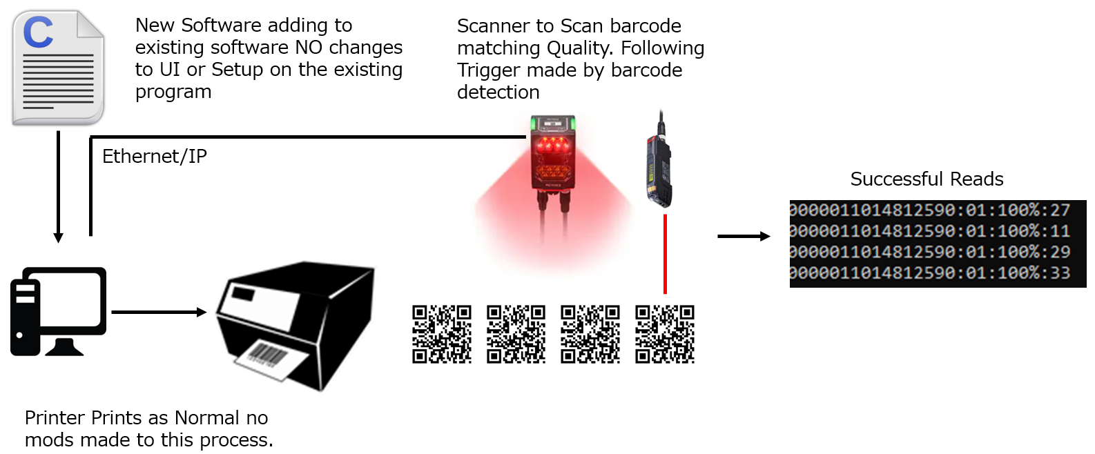

Figure 2.0 – New System Setup

The PC is connected to the printer via RS232. Comms between the printer and the PC must be established to run the software successfully. If there is an issue with serial comms the software will notify the user that a database connection cannot be established and fail to launch.

The SR750 is connected to the PC via ethernet connection.

By default, the scanner is configured to the IP address: **192.168.100.100.**

The PC by default will have a port allocated for WAN and a port allocated to the LAN/Scanner.

The IP address of the Scanner port is set to the following IP: **192.168.100.1**

To ensure a successful connection to the scanner. Open the AutoID Network Navigator software

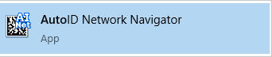

AutoID Network Navigator is a Keyence software that is used for calibration of the SR750.

To setup the SR750 you must firstly setup the scanner on the AutoID software.

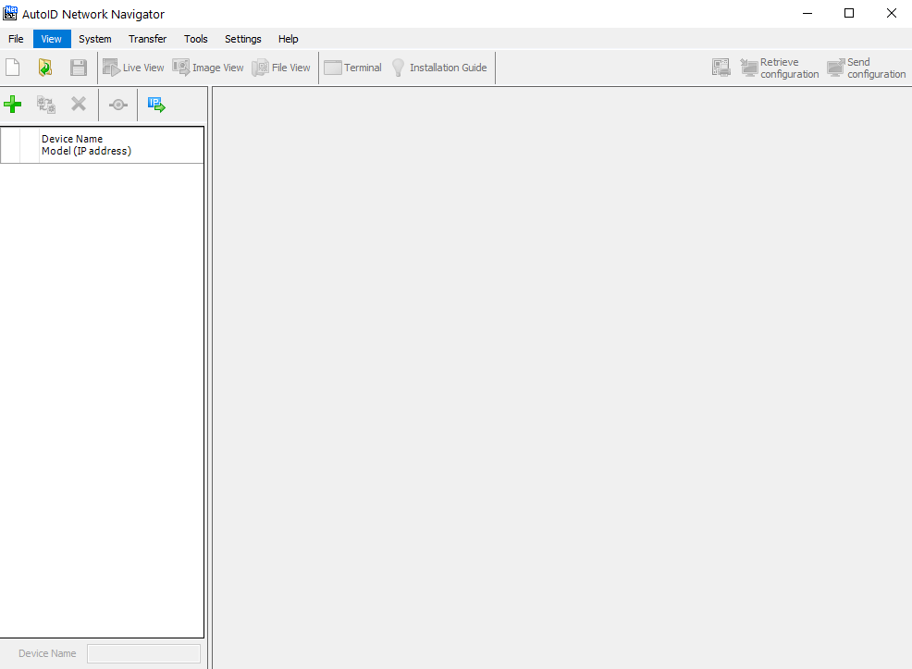

**Figure 3.0: AutoID Software Interface**

To connect to the scanner. Click the ‘+’ icon on the top left corner of the GUI.

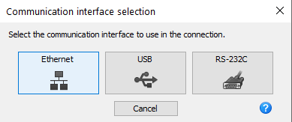

**Figure 4.0: Comms Interface**

Select the Ethernet Comms Interface.

Select the manual connection.

Enter the IP address **192.168.100.100** to access the Scanner and click ok.

The Scanner will appear as a registered device on the list and can now be connected to the software.

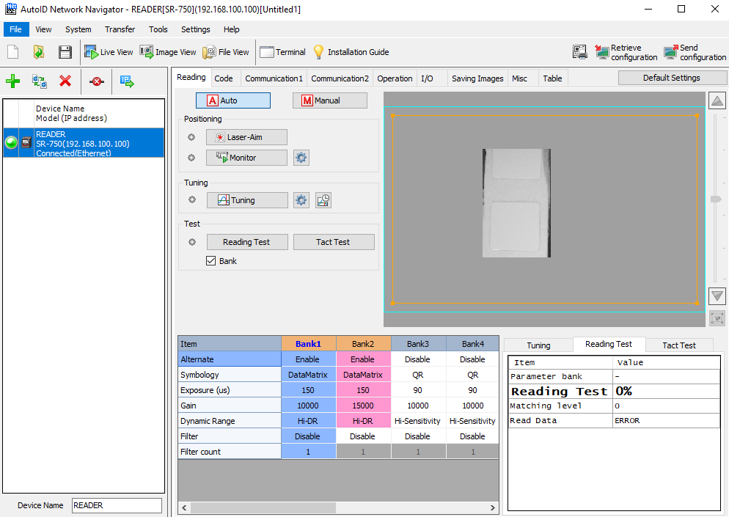

4

2

3

1

**Figure 5.0 AutoID Main Interface**

1. Reader Status – The green LED will indicate if the reader is connected or now. Green for connected and blue for operating.
2. Scanner Camera – The scanner has a camera that will provide a live view. While in operation the user can see live use of the scanner. The Orange outline is the scanner mask. The mask is scalable and provides a more concentrated view for the scanner to detect incoming barcodes.
3. Reading Test – Scanned codes will have their properties shown here. This is a useful tool for assessing incoming codes for their quality and properties.
4. Tunning and Positioning – The operator can from this panel conduct a reading test which will turn on the scanner to read a positioned barcode.

The tuning button will calibrate the scanner to ambient conditions, this will however revert all previous calibration steps beforehand, ensure therefore that this is the FIRST calibration measure to conduct when operating.

The laser aim will produce a targeting laser from the scanner for further calibration of the scanner’s accuracy.

The monitor function will turn the camera to enable a live video for the operator, this is simply a monitoring tool for the operator for use.

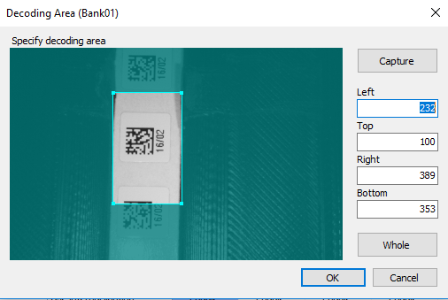

**Figure 6.0 Selecting Decode Area**

Under the manual calibration menu. The operator can select, a portion of the live to focus the camera.

The capture button will enable the operator to re-orient the capture view. The smaller the capture view the more precise the scan. This can be reverted.

As standard it is recommended that the capture view is calibrated to the above F6.0.

Following these steps, the scanner has now been successfully calibrated for use.

By conducting a reading test the following will be shown on the AutoID Network Navigator software.

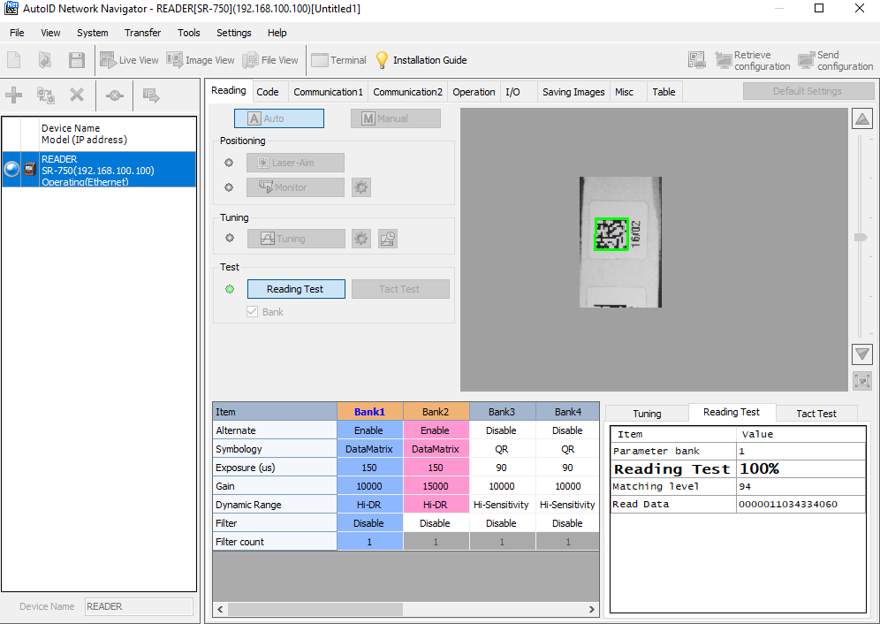

**Figure 7.0 Reading Test with Calibrated Scanner**

The above figure demonstrates a fully calibrated scanner reading a sample barcode. Indicating that the SR750 scanner is now fully calibrated for use with the pcb_print software.

## 

## Operating the Nova pcb_print Software

With the above steps conducted the SR750 scanner is now fully calibrated for use with the printing software.

By default, on the PC desktop, the application file pcb_print.exe will be present and will run the latest batch build of the software. Previous version of the software will be saved to the C2 folder in the C drive of the PC.

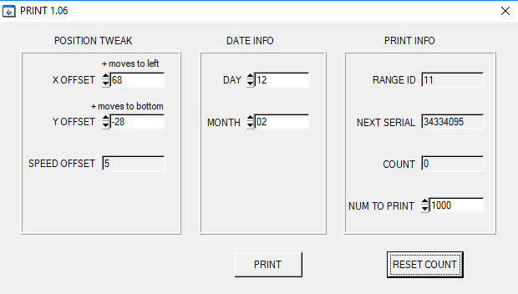

**Figure 10.0 PCB_Print UI**

Running the latest software will provide the operator with the above **(F10.0)** user interface.

Following first start up the zebra printer will require adjustment on the XY offset on how codes are printed. This can be done via the main UI.

The X and Y offset in the position tweak column is used to position the printed code. To print a sample run of barcodes modify the X and Y offset and press the PRINT button. The zebra printer will then print a sample based of the chosen XY offset.

Getting the correct offset settings is a trial-and-error process. It is advised that the code be as central as possible for the best quality reads.

The quantity of labels to print can be modified in the Print Info column. By default, when loading the program, the quantity to print is set to 1000, this can be modified by the operator based on their job requirements.

The print count can be reset following the completion of a job. This is a manual operation must be done via the operator.

Furthermore, the count will not be reset if the process is halted due to bad quality, as will require reset via the operator when the print job is resumed.

## Decoding Scanned Barcodes

The current build of the pcb_print software does not currently display the decoded barcodes during the printing or scanning process.

The feature however can be enabled if needed.

Firstly, go access the following directory: C:\C2\nova\C2_SR750.c

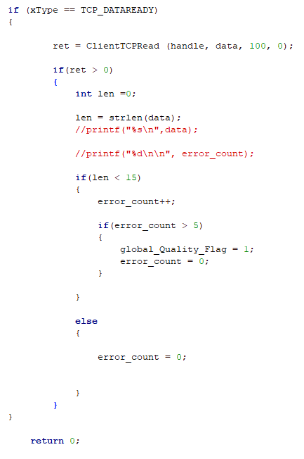

**Figure 11.0: C2_SR750 scanner_callback Function**

Uncomment the printf statements and save the file.

Run a new batch build to build the new project.

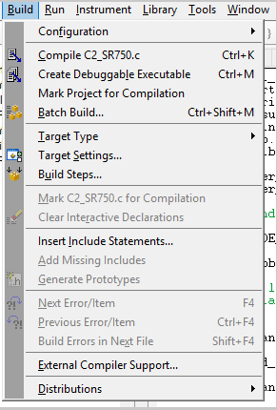

**Figure 12.0 Build Menu**

Select build over the debug version and then select build.

Following the successful build, the .exe application will now launch the latest build.

During the printing process a command line will now open displaying the decoded barcodes



The decoded barcode will display the decoded code. The reading value and the matching quality. The last section of the code will be the matching quality.

The matching quality is a reading of the quality of the scanned code. The current acceptable threshold is >50% of read codes.